**Till Midsems :** [IOT Midsems (UTK)](https://docs.google.com/document/d/1kE4BRZm99G0GP5gEH-oO3JJP5el0x6B47CyVveGfXQc/edit#heading=h.5rwwy3xra9r6)

# **IoT-Lecture-12 HTTP & REST**

**What is Cloud Computing?**

• Collection/group of integrated and networked hardware, software, and Internet infrastructure (called a platform) • Platforms provide on demand services that are always on and accessible anytime and anywhere

**Advantages**: • New applications • Anytime/anywhere access • Homogeneity • Virtualization • Resilient • Cost • Sharing, collaboration • Management/maintenance • Security

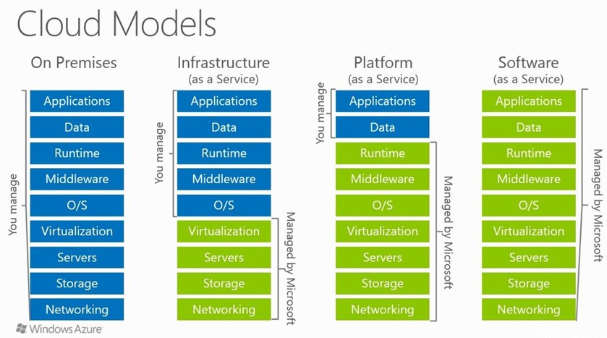

• **Virtualization**: creation of a virtual resource such as a server, desktop, operating system, file, storage, or network

• **Middleware**: software that acts as a bridge between an operating system or database and applications, especially on a network

• **Runtime**: software designed to support the execution of computer programs

**1. Cloud SaaS (Software as a Service):**

* Users access applications hosted by a vendor or service provider over the Internet.
* Applications are provided as a service, including network, servers, operating systems, storage, and some application settings.
* Users typically access SaaS applications through web browsers or program interfaces.
* Users do not manage or control the underlying cloud infrastructure.
* Examples include web-based email, CRM software, business intelligence analytics, and online accounting software,Google Apps, Dropbox, Cisco Webex, Salesforce, Concur, GoToMeeting

**2. Cloud PaaS (Platform as a Service):**

* Users can deploy their own applications onto the cloud infrastructure.
* PaaS offers programming languages, libraries, services, and tools for application development.
* Users do not manage or control the cloud infrastructure but have control over their deployed applications and configuration settings.
* PaaS providers manage the underlying infrastructure, scalability, and maintenance.
* Users typically pay for the services they use.
* Examples include Google App Engine, Microsoft Azure Services, Heroku, OpenShift

**3. Cloud IaaS (Infrastructure as a Service):**

* Users provision fundamental computing resources (processing, storage, networks) on a pay-per-use basis.
* Users can deploy and run arbitrary software, including operating systems and applications.
* Users have control over operating systems, storage, deployed applications, and limited control over select networking components.
* The service provider owns and manages the underlying equipment, including housing, cooling, and maintenance.
* Popular examples include Amazon Web Services (AWS), Microsoft Azure, Google Compute Engine

**Key Differences:**

* SaaS provides complete applications as services, PaaS offers development platforms and tools, while IaaS provides fundamental computing resources.
* In SaaS, users have minimal control over infrastructure and application settings.
* In PaaS, users have control over their applications but not the underlying infrastructure.
* In IaaS, users have more control over the operating systems, applications, and some networking components.
* SaaS is suitable for end-users of applications.
* PaaS is suitable for developers who want to build and deploy applications.
* IaaS is suitable for organizations that want more control over their infrastructure and need to run existing software packages or applications in the cloud.

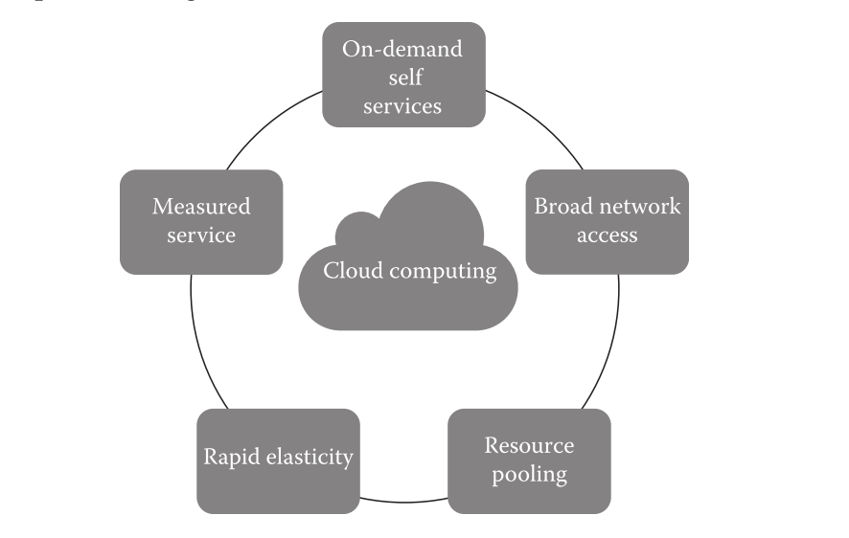

**Virtualization**

* Virtualization is a technology that enables the **single physical infrastructure to function as a multiple logical infrastructure or resources.**
* It involves **abstracting and simulating the underlying hardware and resources**, such as the CPU, memory, storage, and network, to create isolated virtual machines (VMs) or containers.
* These virtual environments can run their own operating systems and applications independently of each other, even though they share the same physical hardware.

Cloud Example:

**Amazon Simple Storage Service (S3)**

• Unlimited storage

• Pay for what you use

**Amazon Elastic Compute Cloud (EC2)**

• Virtual computing environments (“instances”)

• Pre-configured templates for instances

• Launch as many virtual servers as needed (“elastic”)

• Xen and KVM hypervisor

**HyperText Transfer Protocol (HTTP)**

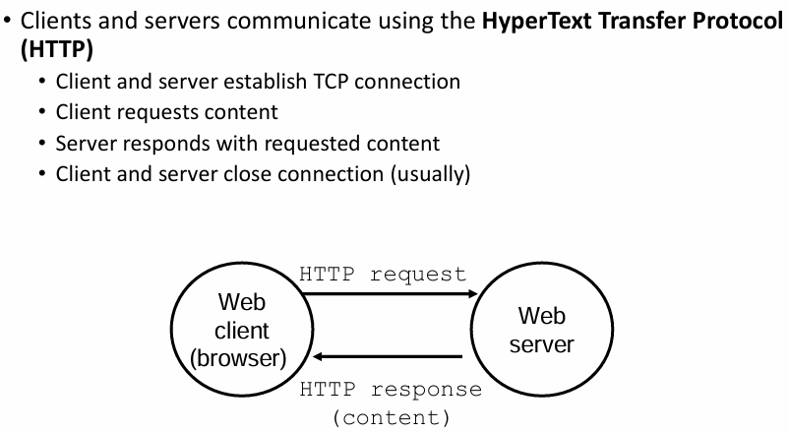

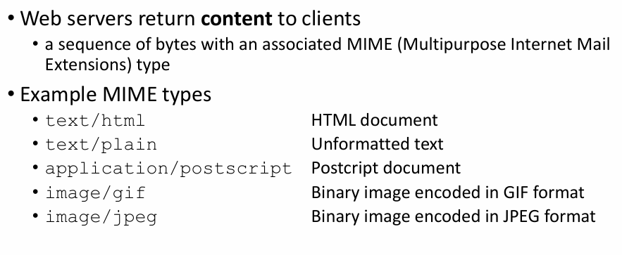

**Static & Dynamic Content**

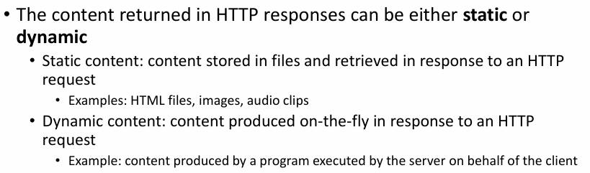

**URLs**

• Each file managed by a server has a unique name called a URL (Universal Resource Locator)

• URLs for static content:

• http://www.cse.nd.edu:80/index.html

•Identifies a file called index.html, managed by a web server at www.cse.nd.edu that is listening on port 80

• URLs for dynamic content:

• http://www.cse.nd.edu:8000/cgi-bin/adder?15000&213

• Identifies an executable file called adder, managed by a web server at www.cse.nd.eduthat is listening on port 8000, that should be called with two argument strings: 15000 and 213

**HTTP REQUEST FORMAT**

**1. Request Line:** This is the first line of the request and contains three crucial pieces of information:

* Method: This specifies the action the client wants the server to perform. Common methods include GET (to retrieve data), POST (to send data), PUT (to update data), and DELETE (to remove data).
* Request-URI: This identifies the specific resource the client is requesting. For example, it could be a web page URL or the path to an image file.
* Protocol Version: This specifies the HTTP version used in the communication (e.g., HTTP/1.1 or HTTP/2).

**2. Request Headers (Optional):** Following the request line, there can be zero or more lines containing request headers. These headers provide additional information to the server about the client and the request itself. Some common headers include:

* User-Agent: Identifies the browser or application making the request.
* Host: Specifies the hostname of the server the request is directed to.
* Referer: Indicates the URL of the webpage that linked to the requested resource.
* Content-Type: If the request includes data (like in a POST request), this header specifies the type of data being sent.

**3. Empty Line**: After all the request headers (if any), a blank line (just a carriage return and line feed) indicates the end of the header section.

**4. Message Body (Optional):** In some cases, the request might also include a message body containing additional data. This is typically used with methods like POST or PUT to send data to the server.

**HTTP methods:**

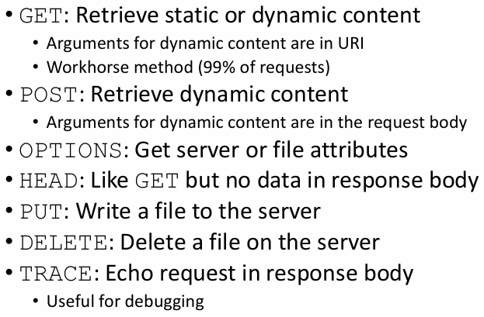

**Structure of an HTTP Response:**

* **Response Line**: The first line, containing three crucial elements:
  + HTTP version used (e.g., HTTP/1.1)
  + Numeric status code indicating the outcome of the request (e.g., 200 for success, 404 for not found)
  + Brief description of the status code in plain English (e.g., "OK", "Not Found")
* **Response Headers (Optional)**: Zero or more lines providing additional details about the response:
  + Content-Type: Specifies the type of data in the message body (e.g., text/html, image/jpeg)
  + Content-Length: Indicates the size of the data in the message body (in bytes)
  + There can be many other headers depending on the specific response and server configuration.
* **Empty Line**: A blank line separating the headers from the message body.
* **Message Body (Optional):** The actual data being sent by the server to the client, such as the content of a web page or an image file.

**Understanding Status Codes:**

* The status code is vital for understanding the success or failure of the request. Here are some common examples:
  + **200 OK:** The request was successful, and the response contains the requested data.
  + **301 Moved Permanently:** The requested resource has been permanently moved to a new location.
  + **403 Forbidden**: The server refuses to fulfill the request due to lack of permissions.
  + **404 Not Found:** The requested resource could not be found on the server.
  + **500 Internal Server Error**: An unexpected error occurred on the server, and the request could not be completed.

**REST (Representational State Transfer):**

Imagine a well-organized library:

* **REST is like a set of rules for how patrons (clients) interact with the library (server) and its resources (books, databases).**
* These resources are clearly defined and can be anything from physical books to digital databases.
* Clients don't need to know the internal workings of the library; they just need to follow the established protocols.

**Key Principles of REST:**

* **Stateless:** Each request from a client (like searching for a book) must contain all the information the server needs, independent of prior requests. It's like starting fresh each time.
* **Client-Server Model:** Clients make requests, and servers process them and deliver the resources or responses. Clients don't directly manipulate data on the server; they interact through requests.
* **Uniform Interface:** REST uses a set of standard methods (verbs) for interacting with resources. These methods include:
  + **GET:** Retrieve a resource (like getting a book from the shelf).
  + **POST:** Create a new resource (like submitting a new book request).
  + **PUT:** Update an existing resource (like editing a book's record).
  + **DELETE:** Delete a resource (like removing a book from the library).
* **Resource-oriented:** Everything revolves around resources. They are identified by URIs (Uniform Resource Identifiers), which act like unique addresses for each resource. Imagine each book having a call number, which is its URI.
* **Representations:** 
  + In REST, representations are essentially the different formats data can be delivered in when a client requests a resource. It's like choosing the presentation style for information retrieved from a server.
  + Common Formats: Two of the most widely used representation formats are:
    - JavaScript Object Notation (JSON): A lightweight and human-readable format that uses key-value pairs to represent data structures. It's popular for its simplicity and ease of parsing by many programming languages.
    - XML (Extensible Markup Language): A more structured format that uses tags and attributes to define data elements. It offers flexibility for complex data structures but can be more verbose compared to JSON.

**Benefits of REST:**

* **Interoperability:** Different applications can easily interact with RESTful web services because they follow the same rules. Anyone with a library card (understanding REST principles) can access the resources (web services).
* **Scalability:** RESTful systems can be easily scaled to handle more users and requests. The library can add more bookshelves (resources) as needed.
* **Maintainability:** RESTful services are easier to understand, modify, and troubleshoot due to their well-defined structure. Librarians can easily update the library catalog (web service) without affecting how patrons access it.

**In essence, REST provides a standardized way to build web services that are flexible, reliable, and easy to use.**

**CoAP**

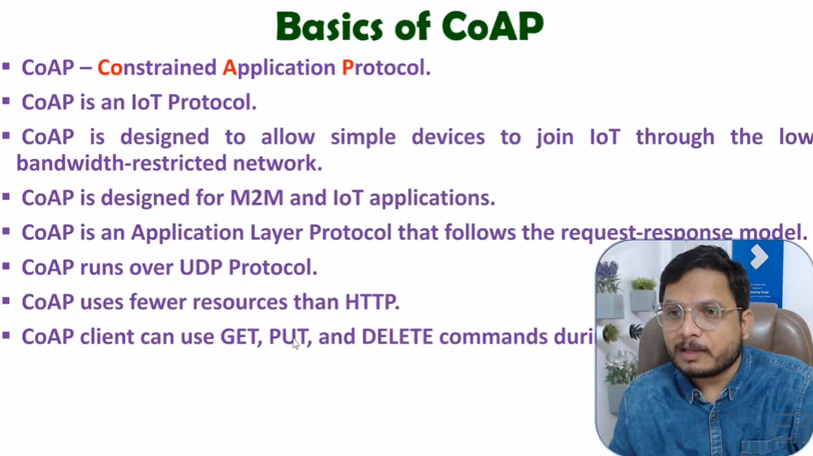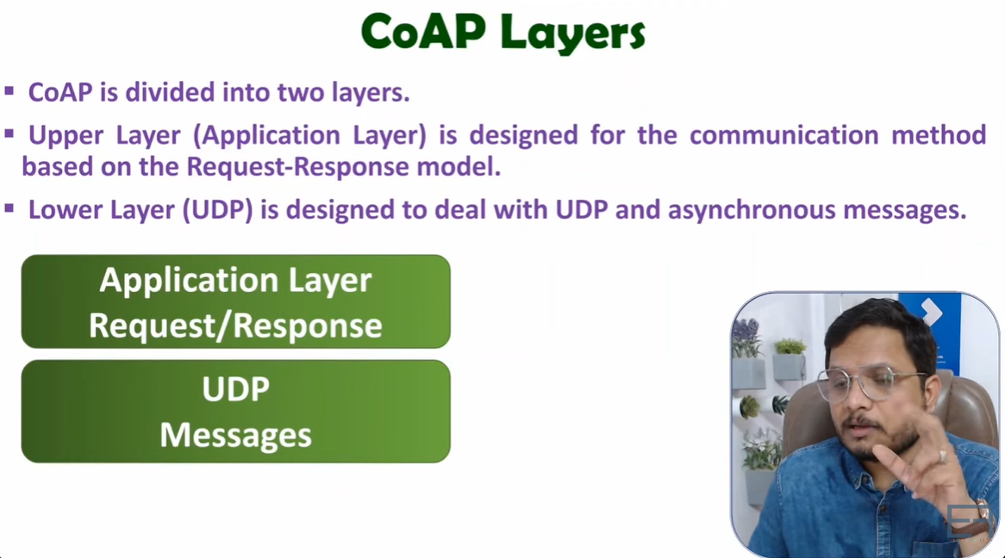

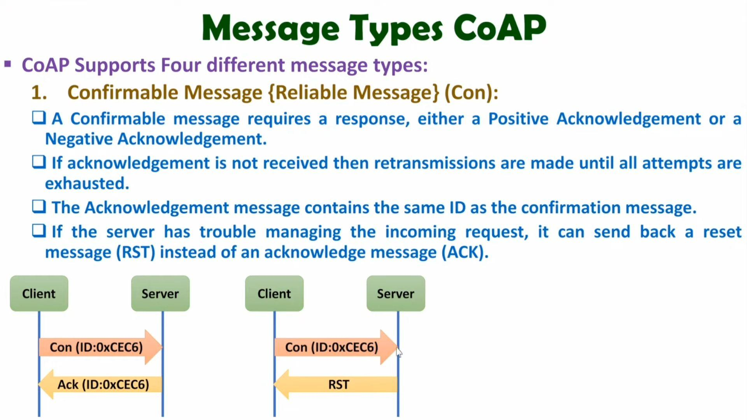

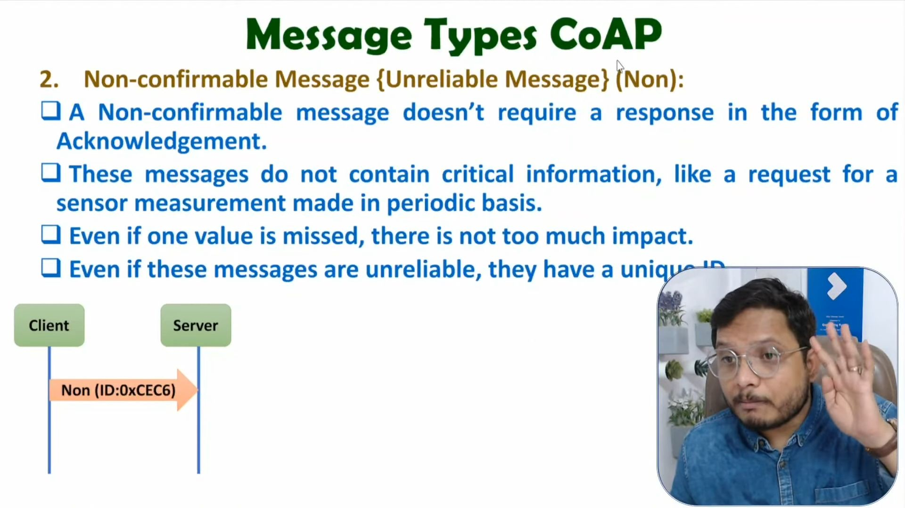

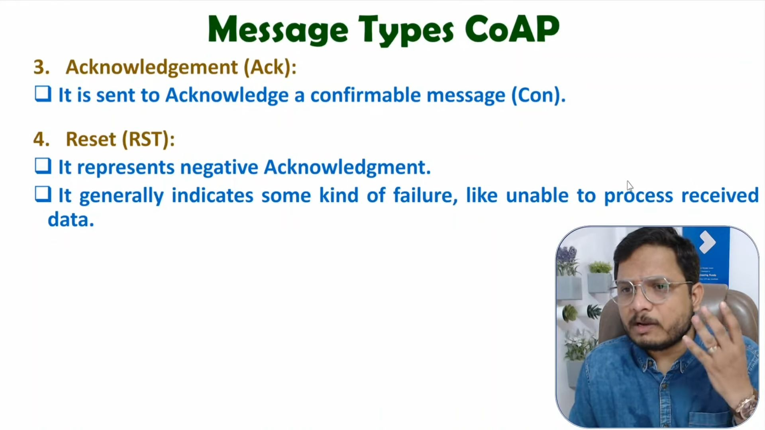

* CoAP provides reliability without using TCP as transport protocol
* CoAP enables asynchronous communication
  + e.g., when CoAP server receives a request which it cannot handle immediately, it first ACKs the reception of the message and sends back the response in an off-line fashion
* Also supports multicast and congestion control
* Both synchronous and asynchronous
* For constrained devices and networks
* Specialized for M2M applications

**MQTT**

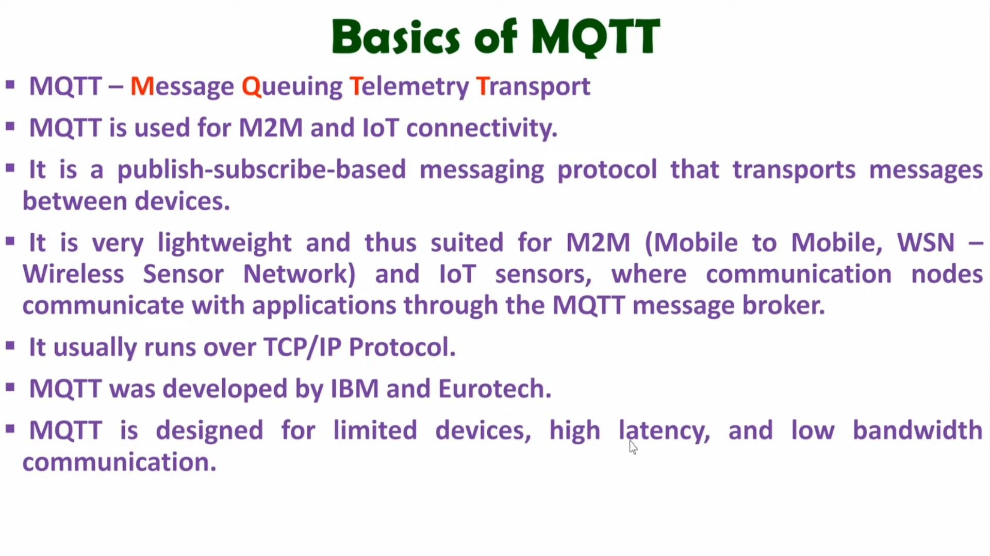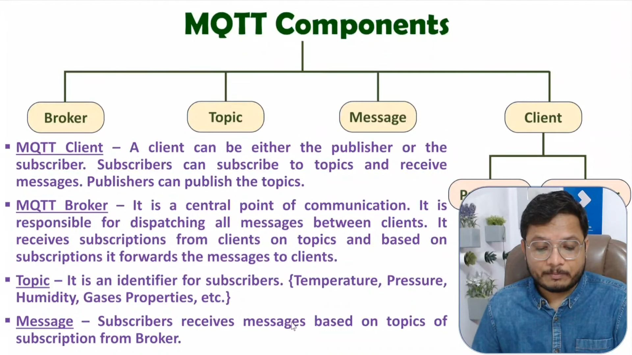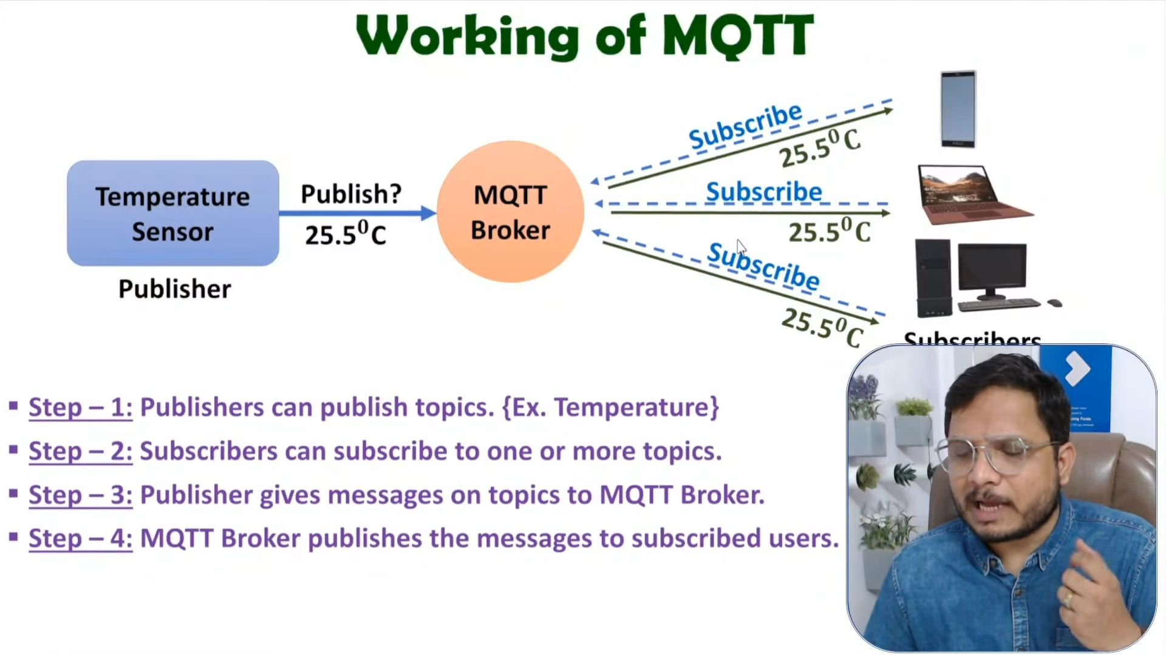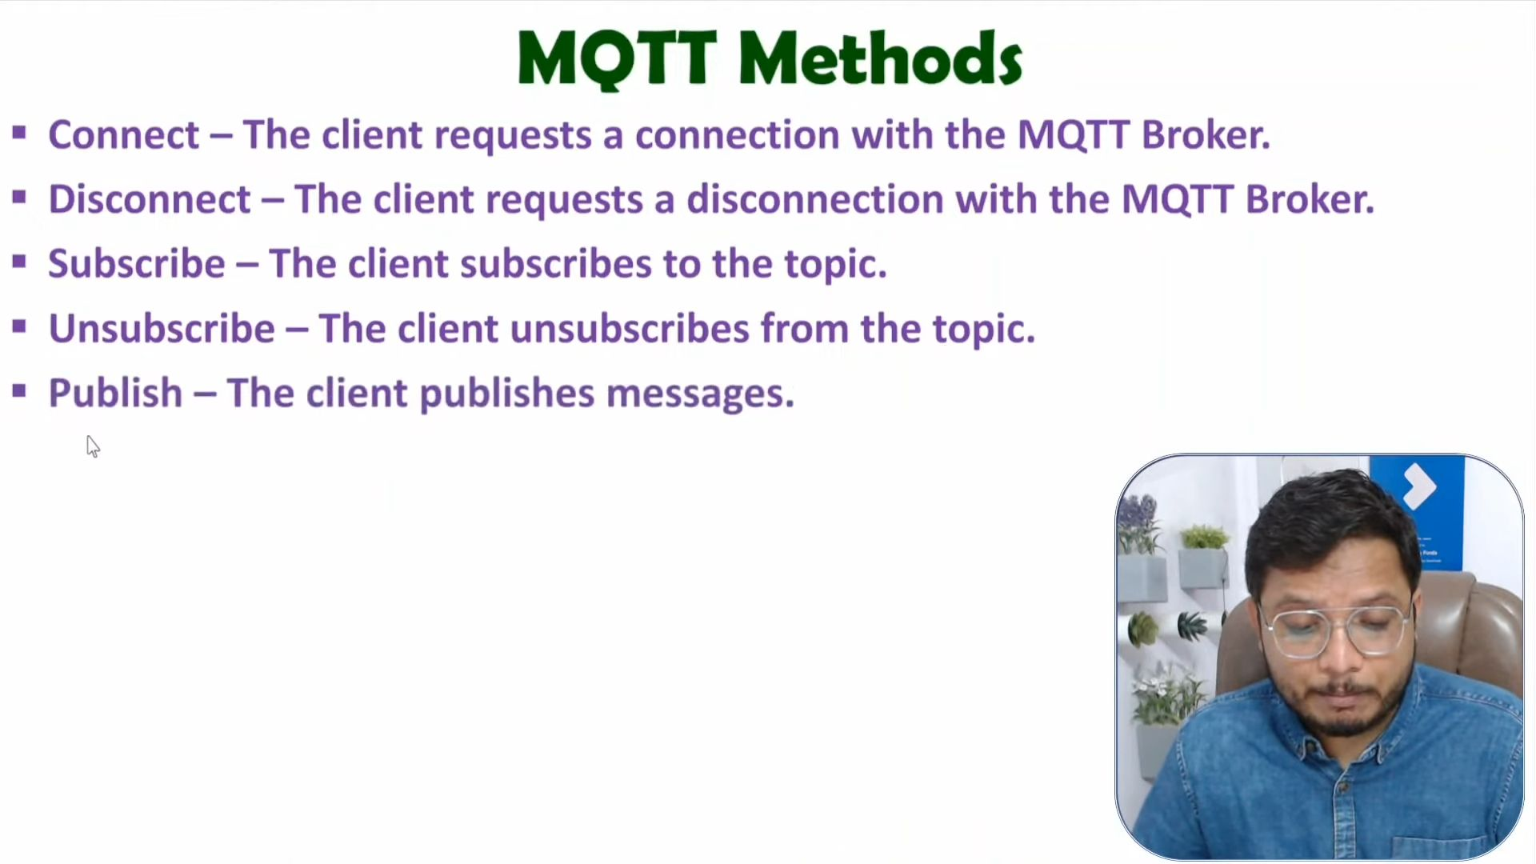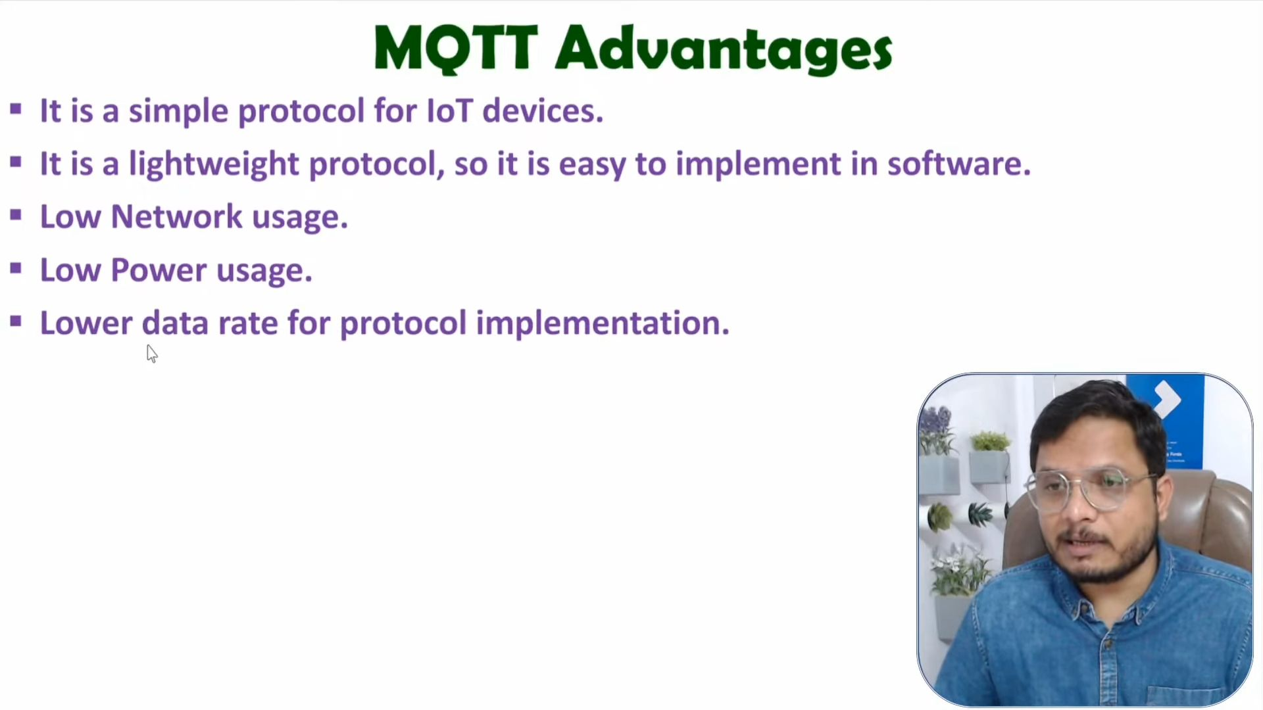

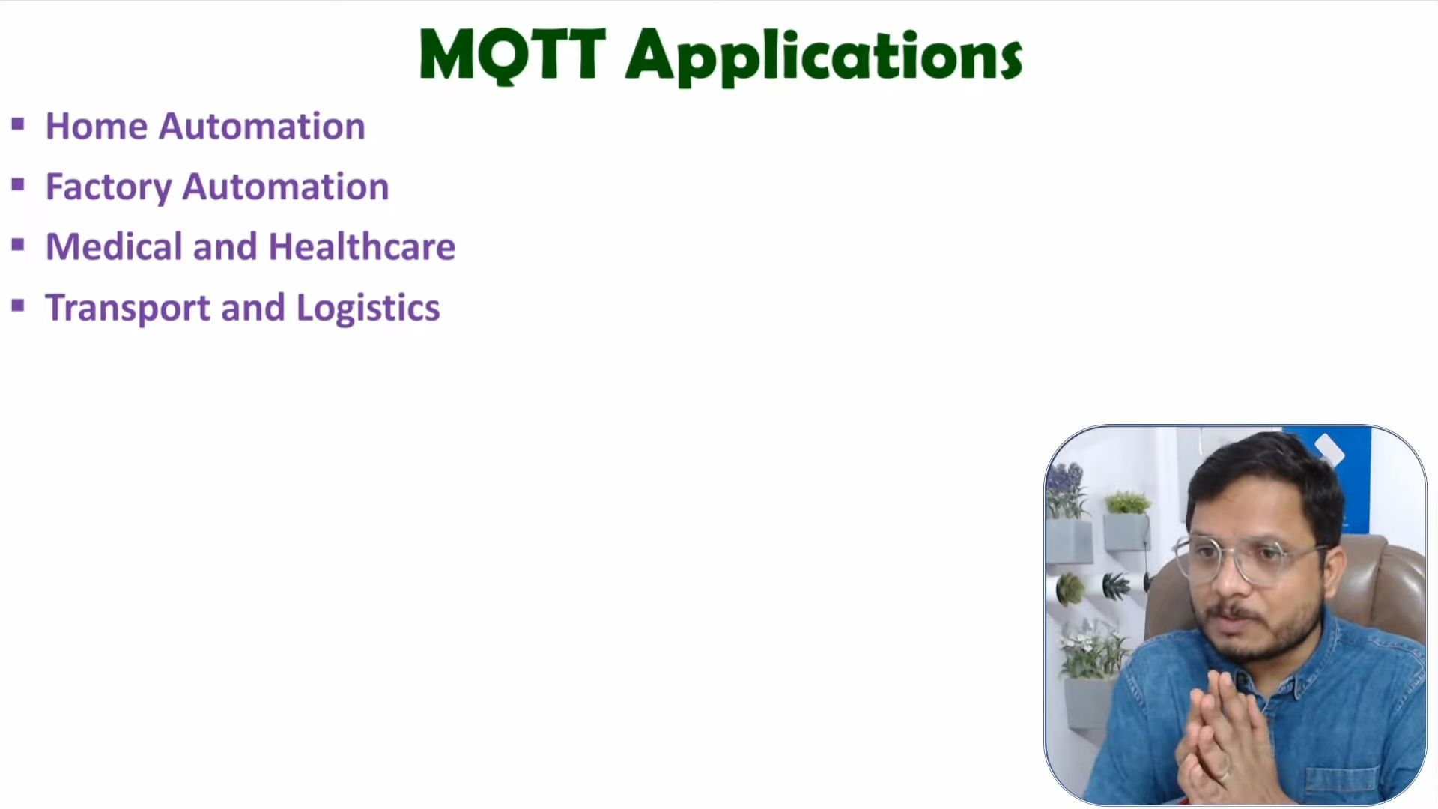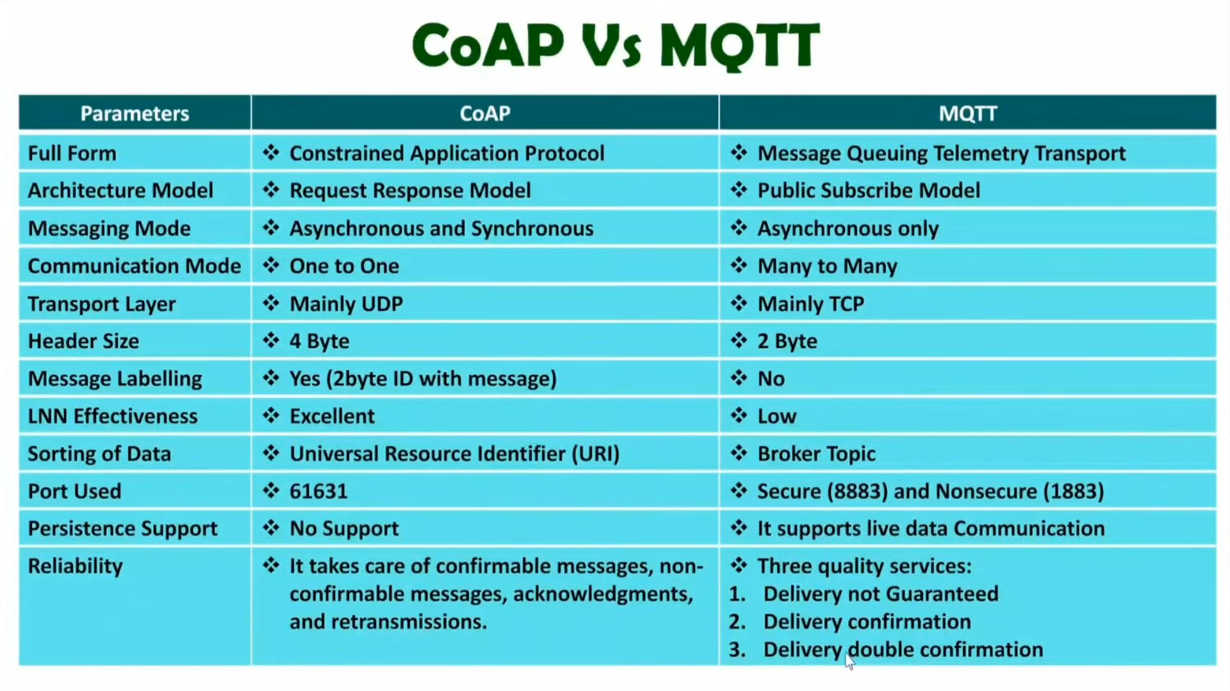

## 

## 

## 

## **Durable and Transient Subscriptions in MQTT**

**Subscriptions:**

* **In MQTT, a subscription allows a client (device, application) to express interest in receiving messages published to a specific topic (channel) on the broker (server).**

**Durable Subscriptions:**

* Persistent Connection: Durable subscriptions are designed to persist even when the client disconnects from the broker.
* Buffered Messages: If the client disconnects while there are messages published to the subscribed topic, the broker buffers (temporarily stores) those messages.
* Delivery upon Reconnection: When the client reconnects to the broker, it receives all the buffered messages it missed while disconnected. This ensures the client doesn't miss any critical information.
* Use Cases: Durable subscriptions are ideal for scenarios where reliable message delivery is essential, and clients might experience intermittent connectivity (e.g., mobile devices, battery-powered sensors).

**Transient Subscriptions:**

* Connection-Bound: Transient subscriptions, as the name suggests, are temporary and only last as long as the client remains connected to the broker.
* No Buffering: If the client disconnects while there are messages published to the subscribed topic, those messages are lost. The client won't receive them.
* Use Cases: Transient subscriptions are suitable for situations where message delivery doesn't need to be guaranteed, or when real-time data and low latency are priorities. Examples include monitoring short-lived events or displaying live sensor readings on a dashboard.

## **State Retention in MQTT: The "Last Known Good" for Newcomers**

State retention, also known as retained messages, is a powerful feature in MQTT that allows storing a single "last known good" message for a specific topic on the broker. This ensures that new clients subscribing to that topic receive the retained message immediately upon connection, even if no new message is currently being published.

Key Characteristics:

* Persistent Publication: A retained message is essentially a regular MQTT message with a special flag set, indicating it should be retained by the broker. Think of it as a sticky note left on a specific topic (bulletin board).
* Immediate Delivery: When a new client subscribes to a topic with a retained message, they receive that message immediately upon connection, without waiting for a new publication. It's like arriving at a meeting and instantly being briefed on the last discussed point (retained message).
* One Flag, Two Locations: The retained flag is set in both:
  + The original publish packet was sent by the publisher to the broker. This tells the broker to store the message for future subscribers. Imagine the publisher attaching a "retain" sticker to the message.
  + The subscription request is sent by the subscriber to the broker. This tells the broker to deliver the retained message if it exists. Think of the subscriber asking the librarian (broker) if there are any important notices (retained messages).
* Single Champion: The broker only stores one retained message per topic. If a new retained message is published for the same topic, it overwrites the previous one. Imagine only having space for one sticky note on the bulletin board; the newest takes precedence.

Why Separate Flags?

* Independent Actions: The publisher's decision to retain a message should be independent of whether any subscribers currently exist. Setting the flag in the published packet allows the publisher to make the message persistent without needing to know if anyone is listening.
* Subscriber Flexibility: The subscriber flag allows new clients to choose whether they want to receive the retained message, even if the publisher didn't explicitly request it. This flexibility can be useful in some scenarios, like a client only interested in the current state, not historical information.

Benefits of State Retention:

* Fast Start-up for New Clients: New subscribers get up-to-speed quickly by receiving the retained message, providing context before receiving new publications.
* Offline Synchronization: Clients who were disconnected can catch up on the latest state by receiving the retained message upon reconnection.

Use Cases for Retained Messages:

* Device Initial Configuration: The retained message can hold default settings or configuration values for new devices subscribing to the topic.
* Current Status Updates: Sensors or devices can publish retained messages with their current status (e.g., "online", "alarm triggered"), which new clients receive immediately.
* Global Application State: A retained message can represent the overall state of an application, providing context for new clients.

In essence, state retention in MQTT offers a mechanism for new clients to quickly get on board by receiving the "last known good" message for a topic, enhancing communication efficiency and overall application awareness.

## 

## 

## 

## **Session Awareness & LWT**

## Session Awareness: Tracks connected clients and their subscriptions.

* **Clean Sessions (Default)**: Simple for short connections. Broker forgets client info on disconnect (resubscription required).
* **Dirty Sessions (Optional)**: More complex. Broker remembers subscriptions and potentially some application state, allowing seamless reconnection without resubscribing.

Last Will and Testament (LWT): A "goodbye" message published by the broker for unexpected disconnects.

* LWT Message: Contains topic, payload ("Device X disconnected"), and QoS (delivery guarantee).
* Works with Both Sessions:
  + Clean Sessions: LWT is crucial, notifying other clients about unexpected disconnects for necessary actions.
  + Dirty Sessions: LWT provides additional context about disconnection (e.g., reason, time) for monitoring and troubleshooting.

Benefits:

* Improved Reliability: LWT ensures notification of unexpected disconnects for proper actions.
* Enhanced Monitoring: LWT aids in monitoring device health.
* Graceful Reconnection (Dirty Sessions): Clients resume communication seamlessly without resubscribing.

## **MQTT QoS**

MQTT's Quality of Service (QoS) offers a spectrum of message delivery guarantees, allowing you to tailor communication to your specific application needs.

**1. QoS 0: At Most Once ("Fire and Forget")**

* Characteristics:
  + Lowest overhead (only 1 PUBLISH message sent by the client).
  + Unreliable Delivery: There's no guarantee the message will be received by the subscriber. It might be lost due to network issues, broker crashes, or other factors.
  + "Fire and Forget": The publisher sends the message and doesn't wait for confirmation.
  + TCP Reliability (Partially Mitigates Issues): Although MQTT QoS 0 doesn't guarantee delivery, the underlying TCP protocol offers some level of inherent reliability through features like retransmissions. However, TCP doesn't guarantee message order or prevent duplicates.
* Use Cases:  
  + Real-time data streams: When data loss is tolerable and low latency is a priority (e.g., sensor readings, live video feeds).
  + Non-critical information that can be resent if necessary.

**2. QoS 1: At Least Once (Possible Duplicates)**

* Characteristics:
  + Increased Overhead (3 messages): The publisher sends the PUBLISH message with a unique Message ID and waits for an acknowledgement (ACK) from the subscriber. If no ACK is received within a timeout, the message is re-sent. This can lead to duplicate messages being delivered.
  + Guaranteed Delivery (Eventually): The message will be delivered at least once, but duplicates are possible.
  + Message ID Tracking: QoS 1 messages include a unique ID that allows the subscriber to confirm receipt (ACK) or request retransmission.
* Client-Broker Interaction
  + Publisher sends PUBLISH message with Message ID.
  + Broker forwards the message and sends an ACK back to the publisher (if message received successfully).
  + Publisher waits for ACK. If no ACK within timeout, resends the message (potential duplicates).
* Use Cases
  + Important information: When message delivery needs to be ensured, but occasional duplicates are acceptable (e.g., sensor alarms, configuration updates).
  + Balance between reliability and efficiency is crucial.

**3. QoS 2: Exactly Once (Slowest but Most Reliable)**

* Characteristics:
  + Highest Overhead (4 messages): A complex handshake ensures message delivery exactly once. This involves multiple messages between publisher, broker, and subscriber for confirmation and acknowledgement.
  + Utmost Reliability: Guarantees the message is delivered exactly once, even in the presence of network issues or retransmissions.
  + Slowest Delivery: Due to the handshake process, QoS 2 can introduce latency.
* Client-Broker Interaction (Simplified):
  + Publisher sends PUBLISH message with Message ID.
  + Broker sends PUBREC (message received) to publisher.
  + Publisher sends PUBREL (ready to finalize) to broker.
  + Broker delivers message and sends PUBCOMP (delivery complete) to publisher.
* Use Cases:
  + Critical data: When message order and ensuring exactly one delivery is essential (e.g., financial transactions, safety-critical systems).
  + Applications where data loss or duplication is unacceptable.

**RFID**

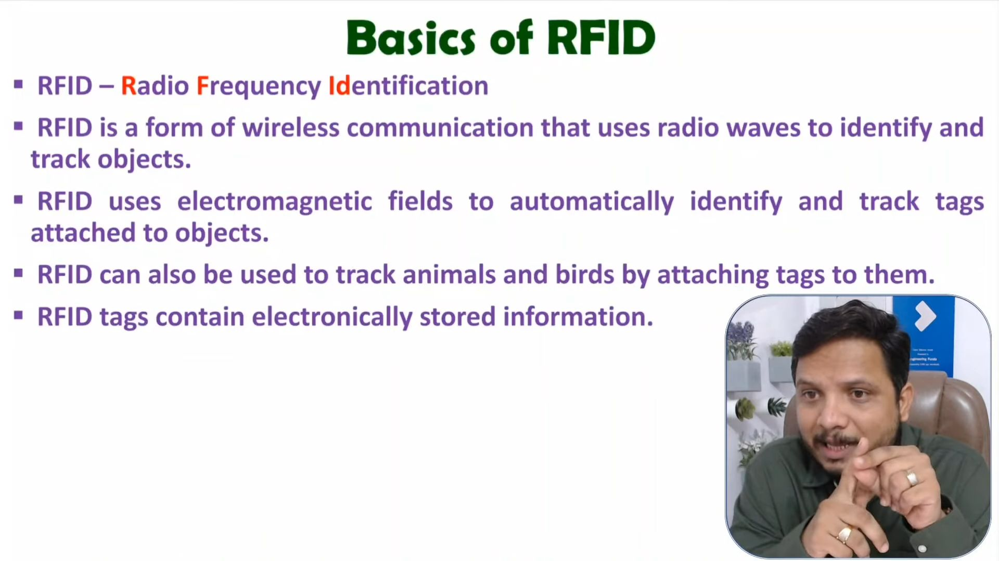

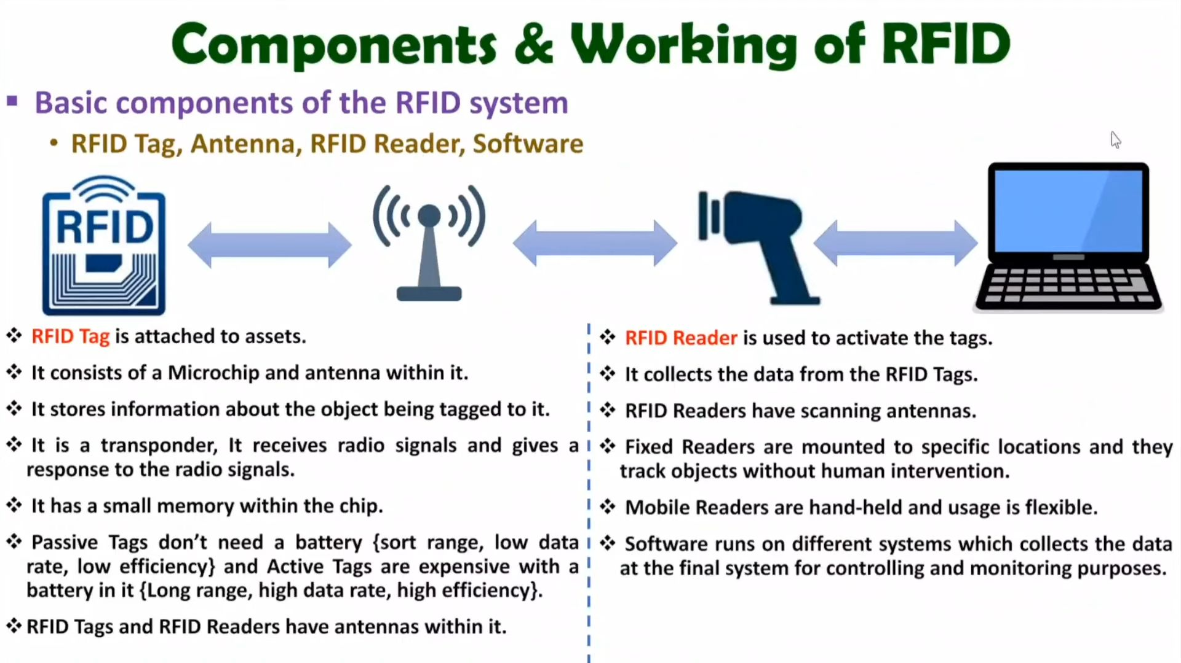

**NFC**

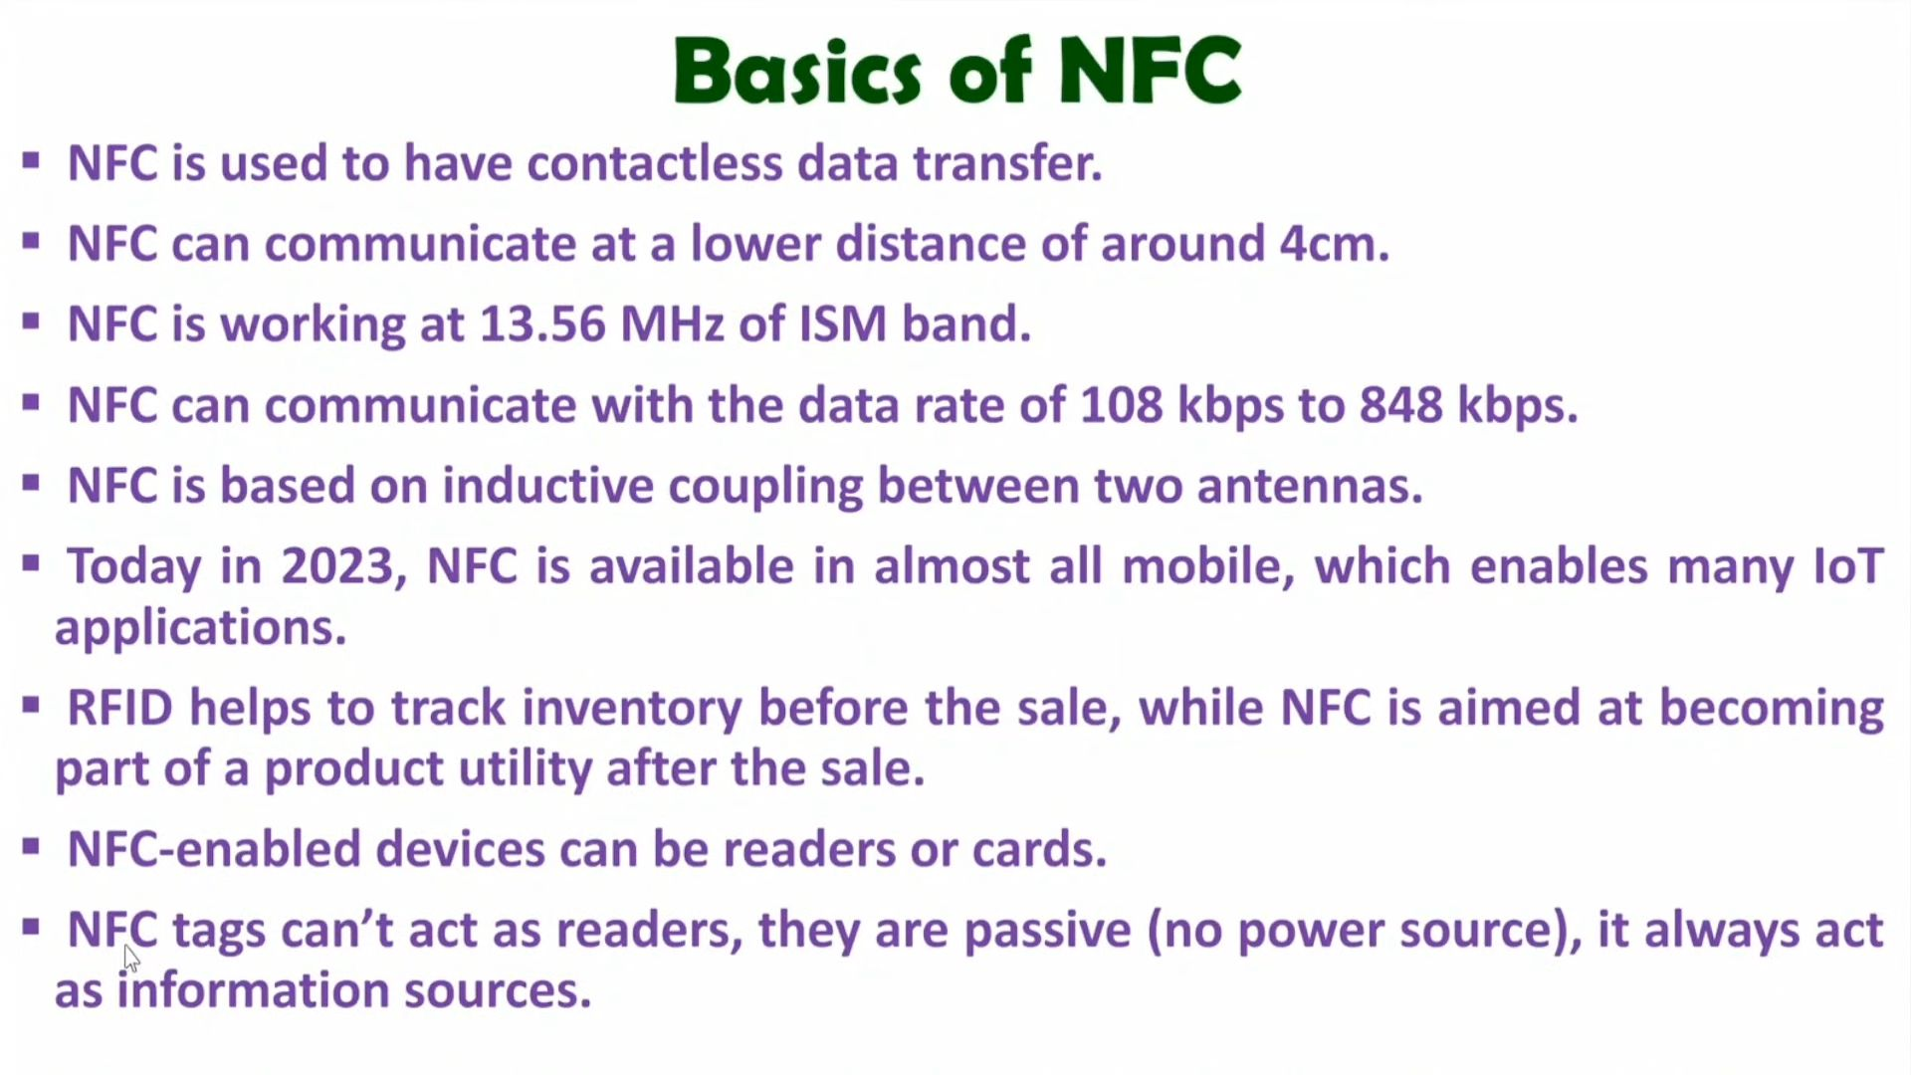

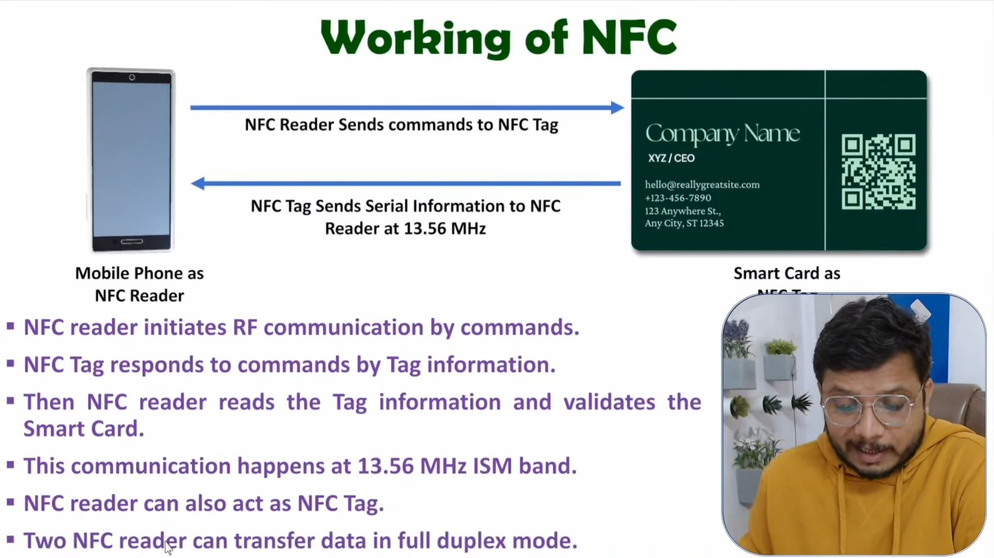

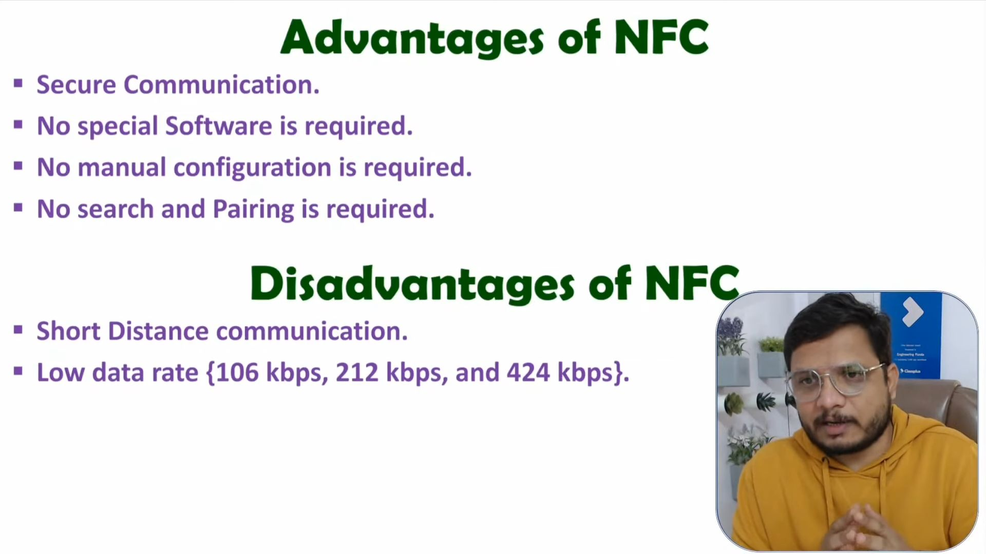

**IEEE 802.15.4 / LR-WPAN**

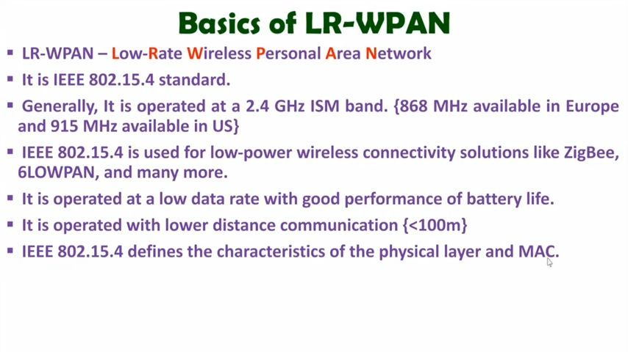

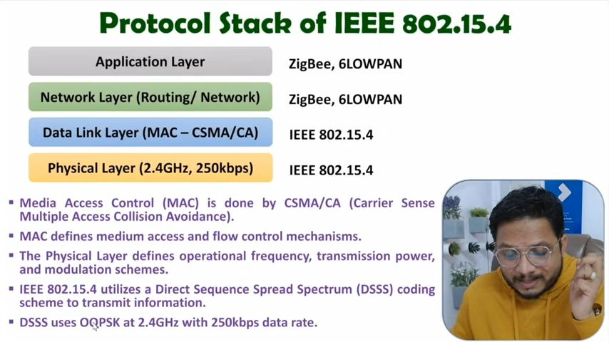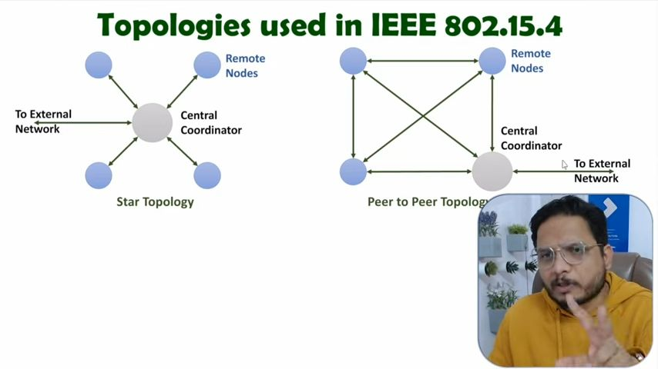

**6LoWPAN**

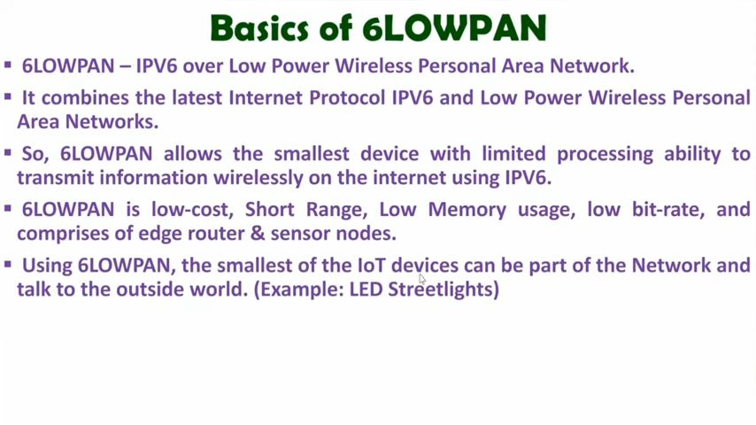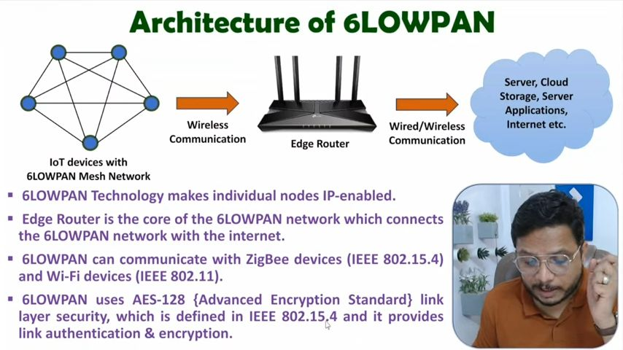

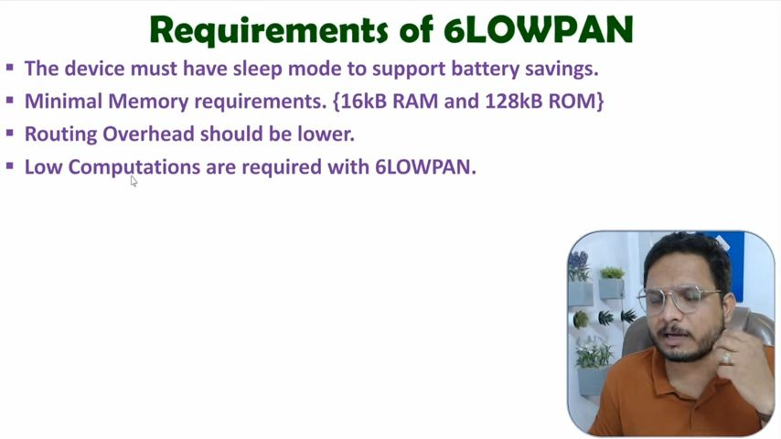

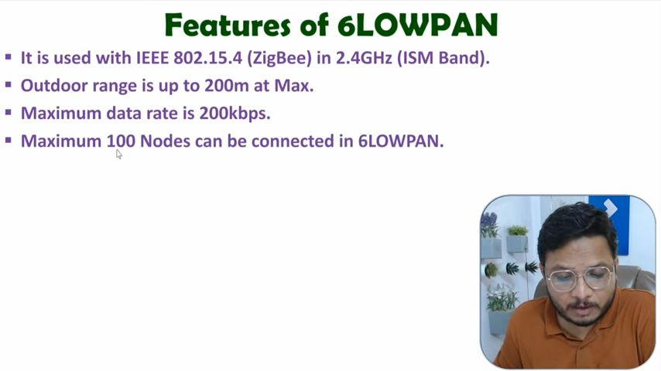

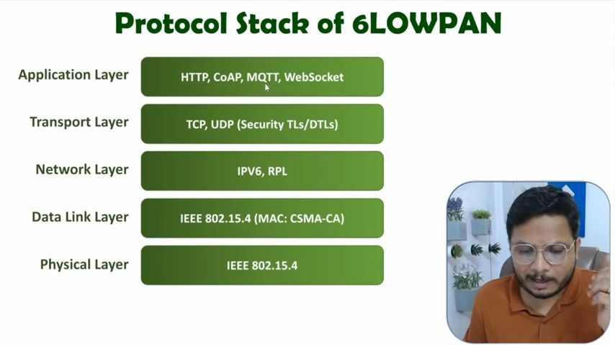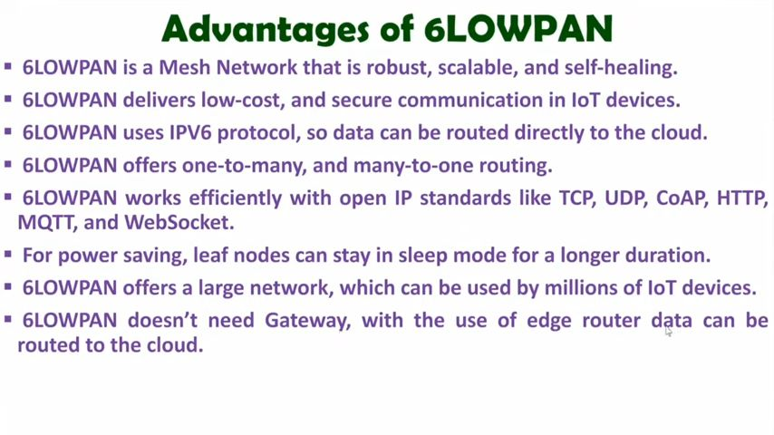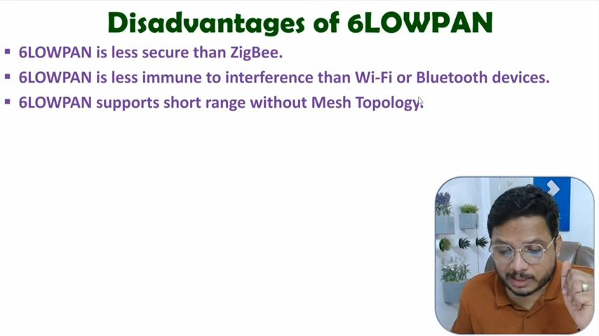

**ZigBee  
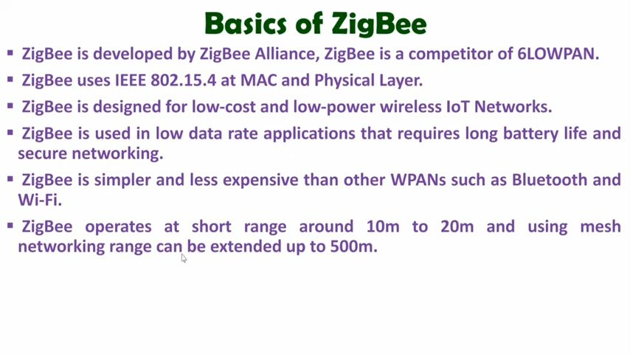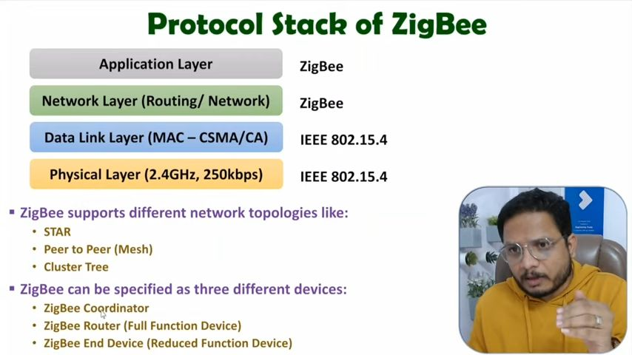**

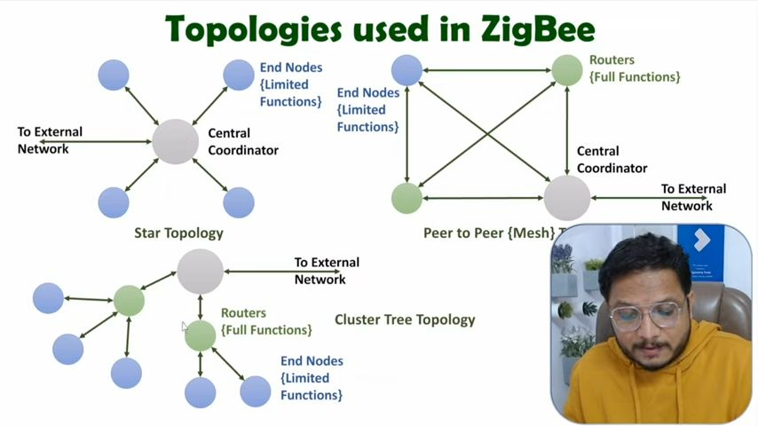

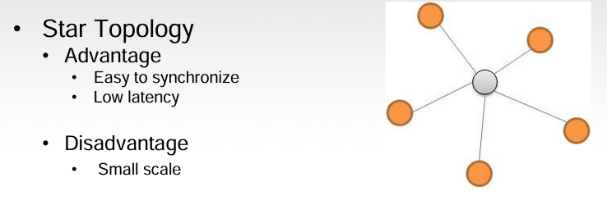

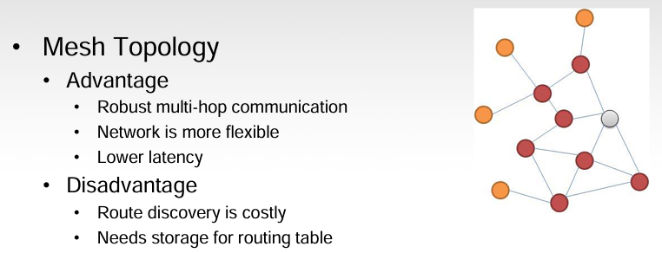

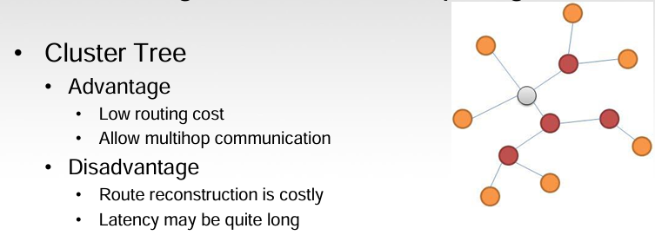

**XBee Device Roles in a ZigBee Network:**

ZigBee networks rely on three main types of XBee devices: Coordinators, Routers, and End Devices. Each plays a specific role in ensuring communication within the network.

**1. Coordinator (One per Network)**

* Selection: The coordinator acts as the central authority figure in a ZigBee network. There can only be one coordinator per network. It's responsible for selecting the communication channel and creating a unique identifier called the PAN ID (Personal Area Network ID) that all devices in the network share.
* Power Source: Coordinators are typically mains-powered due to their constant operational requirement. They are not designed to be battery-powered as they continuously manage the network.
* Addressing: The coordinator has a fixed 16-bit network address of 0000 (all zeros). This special address distinguishes it from other devices in the network.
* Assigning Addresses: The coordinator assigns unique 16-bit short addresses to routers and end devices joining the network. These addresses are crucial for identifying and routing data packets within the network.

**2. Routers (Optional)**

* Function: Routers act as intermediate repeaters in a ZigBee network. They are optional components but can extend the network's reach by relaying data packets between other devices. You can have as many routers as needed to expand your network coverage.
* Power Source: Routers can be mains-powered for reliability or battery-powered for flexibility, depending on the application.
* Joining the Network: When a router is powered on, it automatically searches for a coordinator and requests to join the network using the established PAN ID.
* Communication: Routers can communicate with any device within the network, including coordinators, other routers, and end devices, making them versatile data forwarding nodes.
* Super Router: In some cases, the coordinator itself can act as a "super router," participating in data routing tasks along with dedicated router devices.

**3. End Devices (Optional)**

* Function: End devices are the most basic nodes in a ZigBee network. They are typically battery-powered sensors or actuators that collect or control data. You can have as many end devices as required in your network.
* Joining the Network: Similar to routers, end devices automatically search for a network (coordinator or router) upon startup and attempt to join using the available PAN ID.
* Communication: Unlike routers, end devices can only communicate directly with their parent device, which can be either a coordinator or a router that received their initial join request. They cannot directly communicate with other end devices or the coordinator if not joined through a router.

Key Points:

* The network relies on the coordinator for initialization and overall management.
* Routers provide optional network extension and data forwarding capabilities.
* End devices are battery-efficient nodes for data collection or control.
* The choice of device type (coordinator, router, or end device) depends on the specific requirements of your ZigBee network application.

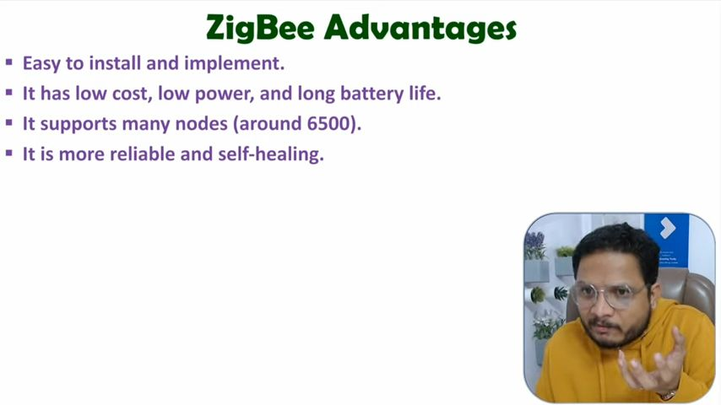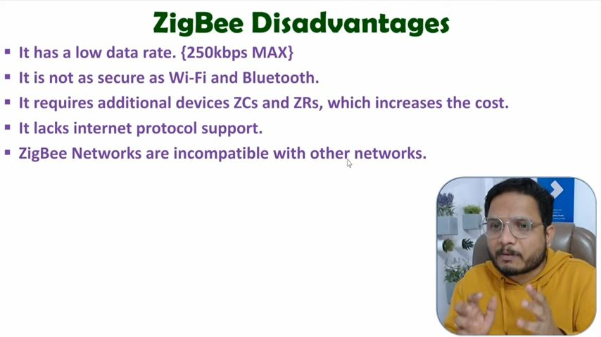

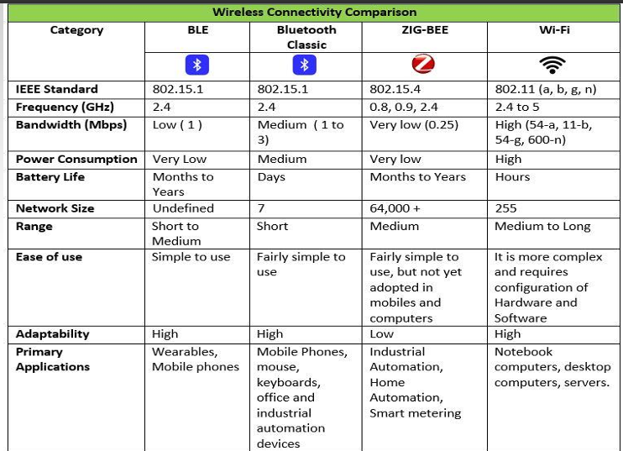

| **Criteria** | **ZigBee** | **6LoWPAN** |
| --- | --- | --- |
| **Internet Connection** | Cannot communicate directly to the internet (requires a ZigBee Gateway) | Can communicate directly to the Internet |
| **Coordinator Role** | The entire network is managed by the Coordinator, does protocol translation at the application layer to send data on server. | No need for a coordinator, all nodes can directly communicate with their IP address. |
| **Reliability** | If the Coordinator fails, then the complete network cannot communicate to the internet. | Network functions even if individual nodes fail, data can be routed through other devices. |
| **Data Rate** | 250 kbps Max | 250 kbps Max |
| **Data Link Layer** | MAC-CSMA/CA (IEEE 802.15.4) | MAC-CSMA/CA (IEEE 802.15.4) |
| **Physical Layer** | IEEE 802.15.4-DSSS (OQPSK) | IEEE 802.15.4-DSSS (OQPSK) |
| **Transport Layer** | None | UDP/TCP |
| **Header Overhead** | 8-16 bytes | 2-11 bytes |

Key Points:

* ZigBee focuses on creating private networks for device communication, while 6LoWPAN enables connection to the internet for wider accessibility.
* ZigBee relies on a central coordinator, whereas 6LoWPAN offers a more distributed network structure with no single point of failure.
* Both utilize the same underlying data link and physical layers but differ in higher-level protocols (ZigBee uses its own, 6LoWPAN uses IPv6).
* 6LoWPAN introduces a smaller header overhead compared to ZigBee, potentially improving efficiency.

## **XBee Comparison Table (ZB vs ZB S2 vs ZB S2C)**

| **Feature** | **XBee ZB** | **XBee ZB S2** | **XBee ZB S2C** |
| --- | --- | --- | --- |
| **Indoor/Urban Range** | Up to 100 ft (30m) | Up to 133 ft (40m) | Up to 200 ft (60m) |
| **Outdoor Line-of-Sight Range** | Up to 300 ft (100m) | Up to 400 ft (120m) | Up to 4000 ft (1200m) |
| **Transmit Power Output** | 1 mW (0dBm) | 2 mW (+3dBm) | 6.3mW (+8dBm) Boost mode, 3.1mW (+5dBm) Normal mode |
| **RF Data Rate** | 250 Kbps | 250 Kbps | 250 Kbps |
| **Receiver Sensitivity** | -92dBm (1% PER) | -98dBm (1% PER) | -102dBm (1% PER) Boost mode, -100dBm (1% PER) Normal mode |
| **Supply Voltage** | 2.8 - 3.4 V | 2.8 - 3.6 V | 2.1 - 3.6V |
| **Transmit Current** | 45 mA (@ 3.3 V) | 40 mA (@ 3.3 V) | 45 mA (+8dBm) Boost mode, 33 mA (+5dBm) Normal mode |
| **Idle/Receive Current (typical)** | 50 mA (@ 3.3 V) | 40 mA (@ 3.3 V) | 31 mA (+8dBm) Boost mode, 28 mA (+5dBm) Normal mode |
| **Power-down Current** | 10 uA | 1 uA | < 1 uA |
| **Frequency** | ISM 2.4 GHz | ISM 2.4 GHz | ISM 2.4 GHz |
| **Dimensions** | Through-Hole: 0.960" x 1.087", SMT: 0.866" x 1.33" x 0.120" | Through-Hole: 0.960" x 1.087", SMT: 0.866" x 1.33" x 0.120" | Through-Hole: 0.960" x 1.087", SMT: 0.866" x 1.33" x 0.120" |
| **Operating Temp** | -40 to 85 °C | -40 to 85 °C | -40 to 85 °C |
| **Antenna Options** | PCB, Integrated Whip, U.FL, RPSMA | PCB, Integrated Whip, U.FL, RPSMA | Through-Hole: PCB, Integrated Whip, U.FL, RPSMA, SMT: RF pad, PCB, or U.FL |
| **Network Topologies** | Point to point, Star, Mesh (with DigiMesh firmware) | Point to point, Star, Mesh | Point to point, Star, Mesh |
| **Channels** | 16 Direct Sequence Channels | 16 Direct Sequence Channels | 16 Direct Sequence Channels |
| **Filtration Options** | PAN ID, Channel & Source/Destination | PAN ID, Channel & Source/Destination | PAN ID, Channel & Source/Destination |

Key Points:

* XBee ZB S2 and ZB S2C offer an improved range compared to the original XBee ZB.
* ZB S2C boasts the most extended outdoor range due to its higher transmit power.
* ZB S2C has the lowest power consumption in idle/receive mode.
* All three models share the same data rate, frequency, and operating temperature range.
* Antenna options and network topologies remain consistent across all models.

**SDN**

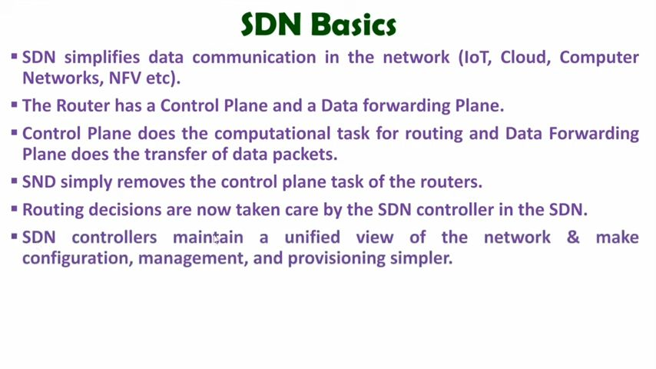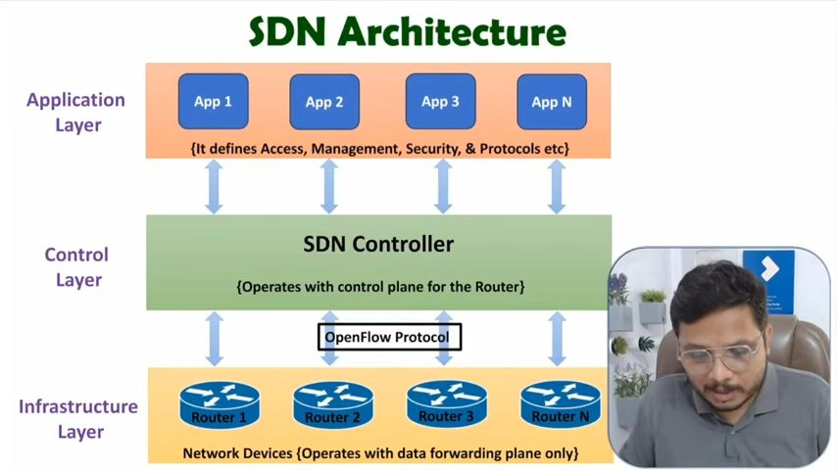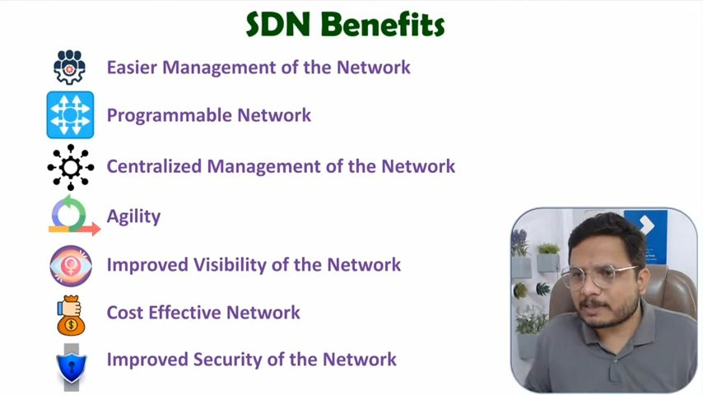

**SDN Architecture**

A typical SDN architecture consists of three layers.

* **Application layer**: It contains the typical network applications like intrusion detection, firewall, and load balancing
* **Control laye**r: It consists of the SDN controller which acts as the brain of the network. It also allows hardware abstraction to the applications written on top of it.
* **Infrastructure layer**: This consists of physical switches that form the data plane and carry out the actual movement of data packets

## **Traditional Networking vs. SDN Architecture: A Breakdown**

**Traditional Networking:**

* **Distributed Control:** Each switch has its own control plane responsible for routing decisions.
* **Control Plane Communication:** Switches exchange topology information to build forwarding tables.
* **Limited Flexibility:** Network configuration changes require manual adjustments on individual switches.

**SDN Architecture (Software-Defined Networking):**

* **Centralized Control:** A dedicated SDN controller manages the entire network.
* **Decoupled Planes:** Control plane (SDN controller) is separated from the data plane (switches) by software.
* **Flow Tables**: Switches use flow tables with match fields and instructions for packet forwarding.
  + Match fields: Identify specific packet characteristics (e.g., source IP, destination port).
  + Instructions: Specify actions on matching packets (e.g., forward to a port, drop packet).
* **Flow Table Management:**
  + SDN controller populates flow tables with instructions on how to handle specific traffic types.
  + If a switch encounters a packet with no matching flow entry (flow miss):
    - The switch sends a message to the controller (packet-in).
    - The controller analyzes the packet and generates a new flow table entry with appropriate instructions.
    - The controller sends the new flow entry back to the switch.

**Overall, SDN architecture offers a programmable and centralized approach to network management, enhancing flexibility and automation for complex network environments.**

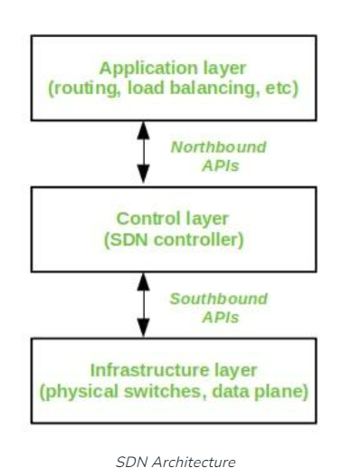

**SDN vs. Traditional Networking**

| **Feature** | **Software-Defined Networking (SDN)** | **Traditional Networking** |
| --- | --- | --- |
| **Approach** | Virtual networking | Conventional hardware-based networking |
| **Control** | Centralized control plane | Distributed control spread across devices |
| **Programmability** | Programmable network behavior | Non-programmable, relies on pre-configured devices |
| **Interfaces** | Open interfaces for programmability and automation | Closed interfaces, limited configuration flexibility |
| **Data & Control Planes** | Decoupled (separated) by software | Integrated (combined) within network devices |
| **Communication Overhead** | Yes | No |
| **Error Prone Configuration** | NO | Yes |

## **Soft-WSN: SDN-powered WSN Management for IoT**

**Components of Soft-WSN:**

1. **Device Management:** This component focuses on managing individual sensor nodes within the network. It offers three key functionalities:
   * Sensor Management: This allows you to choose sensors based on the specific application requirements. You can select from a variety of sensors available in the network to collect the desired data.
   * Delay Management: You can dynamically set the delay for sensor data acquisition. This is helpful in scenarios where real-time data is not critical, and you can optimize power consumption by adjusting the sensing frequency.
   * Active Sleep Management: This enables control over the sleep/wake cycles of sensor nodes. By putting nodes in low-power sleep mode during inactive periods, you can significantly extend their battery life.
2. **Topology Management**: This component deals with the network structure and data flow between nodes. It allows for
   * Node Specific Management: You can modify the forwarding logic of individual sensor nodes. This enables you to create custom routing paths for specific data types or prioritize traffic from critical sensors.
3. **Network Specific Management**: This offers broader control over network-wide traffic flow. It allows you to:
   * Forward All Traffic of a Node: You can direct all data from a particular node to be forwarded through the network for collection and analysis.
   * Drop All Traffic of a Node: If a sensor node malfunctions or becomes compromised, you can choose to drop all its traffic, preventing the spread of corrupted data within the network.

**Benefits of Soft-WSN:**

* **Dynamic Control:** Enables real-time adjustments to sensor behavior, sleep schedules, and data forwarding based on application needs.
* **Improved Performance**: Optimizes network performance by managing data flow and sensor operations.
* **Increased Packet Delivery:** The intelligent controller optimizes routing, leading to more successful data packet deliveries.
* **Enhanced Scalability:** The modular design allows for easy integration with new sensors and devices as the network grows.
* **Power Efficiency:** Active sleep management helps conserve battery life of sensor nodes.
* **Increased Adaptability:** Soft-WSN can be customized to cater to a wide range of IoT applications.
* **Centralized Management & Security**: Manage and secure the entire network from a central point for greater control and efficiency.
* **Reduced message overhead** through centralized control and targeted communication, minimizing unnecessary transmissions.

**Sensor Open flow: Enabling SDN enabled wireless Network.**

* **Programmable Data Plane:** Sensor nodes become programmable data forwarding elements, similar to switches in a wired network.
* **Flow Tables**: Each sensor node maintains a flow table with instructions for handling specific data types.
* **Centralized Control**: An SDN controller manages the entire network, dynamically configuring flow tables on sensor nodes.

| **Feature** | **SOF (Sensor OpenFlow)** | **Soft-WSN** |
| --- | --- | --- |
| **Focus** | Centralized control, programmable data plane | Component-based WSN management |
| **Implementation** | OpenFlow protocol (likely) | Modular framework |
| **Scope** | Adaptability, configuration | Device, topology, and network management |

**LoRaWAN**

